Krugman’s Book Module 4 Questions – Comparative Advantage

Check your Understanding
- In Italy, an automobile can be produced by 8 workers in one day and a washing machine by 3 workers in one day. In the United States, an automobile can be produced by 6 workers in one day, and a washing machine by 2 workers in one day.
- Which country has an absolute advantage in the production of automobiles? In washing machines?
- Which country has a comparative advantage in the production of washing machines? In automobiles?
- What type of specialization results in the greatest gains from trade between the two countries?
- Refer to the story of Tom and Hank illustrated by Figure 4.1 in the text. Explain why Tom and Hank are willing to engage in a trade of 1 fish for 1 and 1 ⁄2 coconuts.
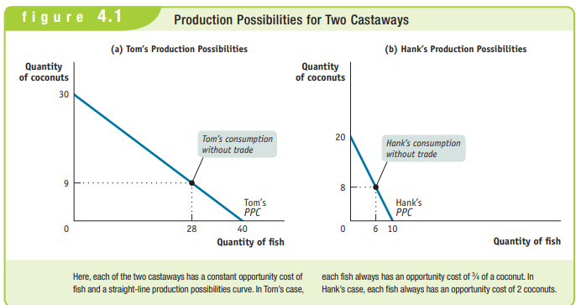

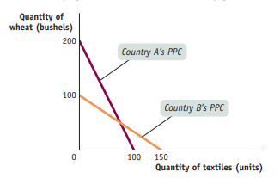
Multiple Choice
- Use the graph to determine which country has an absolute advantage in producing each good.
Absolute advantage in wheat | Absolute in textile production
- Country A Country B
- Country A Country A
- Country B Country A
- Country B Country B
- Country A Neither Country
- For country A, the opportunity cost of a bushel of wheat is
- 1 ⁄2 units of textiles
- 2 ⁄3 units of textiles
- 11 ⁄3 units of textiles
- 11 ⁄2 units of textiles
- 2 units of textiles
- Use the graph to determine which country has a comparative advantage in producing each good. Comparative advantage in wheat production | Comparative advantage in textile production
- Country A Country B
- Country A Country A
- Country B Country A
- Country B Country B
- Country A Neither Country
- If the two countries specialize and trade, which of the choices below describes the countries’ imports? Import Wheat Import Textiles
- Country A Country A
- Country A Country B
- Country B Country B
- Country B Country A
- Neither Country Country B
- What is the highest price Country B is willing to pay to buy wheat from Country A?
- 1 ⁄2 units of textiles
- 2 ⁄3 units of textiles
- 1 unit of textiles
- 11 ⁄2 units of textiles e. 2 units of textiles

Tackle the Free Response Questions
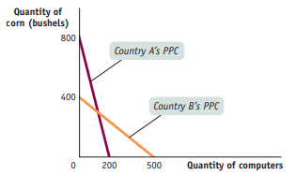
- Refer to the graph below to answer the following questions.
  - What is the opportunity cost of a bushel of corn in each country?
  - Which country has an absolute advantage in computer production? Explain.
  - Which country has a comparative advantage in corn production? Explain.
  - If each country specializes, what good will Country B import? Explain.
  - What is the minimum price Country A will accept to export corn to Country B? Explain.

- Refer to the table below to answer the following questions. These two countries are producing textiles and wheat using equal amounts of resources
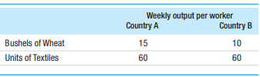
- What is the opportunity cost of producing a bushel of wheat for each country?
- Which country has the absolute advantage in wheat production?
- Which country has the comparative advantage in textile production? Explain

Answers
Module 4
Check Your Understanding
1. a. The United States has an absolute advantage in automobile production because it takes fewer Americans (6) to produce a car in one day than it takes Italians (8). The United States also has an absolute advantage in washing machine production because it takes fewer Americans (2) to produce a washing machine in one day than it takes Italians (3).
b. In Italy the opportunity cost of a washing machine in terms of an automobile is 3⁄8. In other words, 3⁄8 of a car can be produced with the same number of workers and in the same time it takes to produce 1 washing machine. In the United States the opportunity cost of a washing machine in terms of an automobile is 2⁄6 = 1⁄3. In other words, 1⁄3 of a car can be produced with the same number of workers and in the same time it takes to produce 1 washing machine. Since 1⁄3 < 3⁄8, the United States has a comparative advantage in the production of washing machines: to produce a washing machine, only 1⁄3 of a car must be given up in the United States but 3⁄8 of a car must be given up in Italy. This means that Italy has a comparative advantage in automobiles. This can be checked as follows. The opportunity cost of an automobile in terms of a washing machine in Italy is 8⁄3, equal to 22⁄3. In other words, 22⁄3 washing machines can be produced with the same number of workers and in the time it takes to produce 1 car in Italy. And the opportunity cost of an automobile in terms of a washing machine in the United States is 6⁄2, equal to 3. In other words, 3 washing machines can be produced with the same number of workers and in the time it takes to produce 1 car in the United States.
c. The greatest gains are realized when each country specializes in producing the good for which it has a comparative advantage. Therefore, based on this example, the United States should specialize in washing machines and Italy should specialize in automobiles.
2. At a trade of 1 fish for 11⁄2 coconuts, Hank gives up less for a fish than he would if he were producing fish himself—that is, he gives up less than 2 coconuts for 1 fish. Likewise, Tom gives up less for a coconut than he would if he were producing coconuts himself—with trade, a coconut costs 11⁄2 = 2⁄3 of a fish, less than the 4⁄3 of a fish he must give up if he does not trade.
Tackle the Test:
Multiple-Choice Questions 1. a 2. a 3. a 4. d 5. d
Tackle the Test:
Free-Response Questions
2. a. Country A: opportunity cost of 1 bushel of wheat = 4 units of textiles Country B: opportunity cost of 1 bushel of wheat = 6 units of textiles b. Country A has an absolute advantage in the production of wheat (15 versus 10) c. Country A: opportunity cost of 1 unit of textiles = 1⁄4 bushel of wheat Country B: opportunity cost of 1 unit of textiles = 1⁄6 bushel of wheat Country B has the comparative advantage in textile production because it has a lower opportunity cost of producing textiles. (Alternate answer: Country B has the comparative advantage in the production of textiles because Country A has a comparative advantage in the production of wheat based on opportunity costs shown in part a.) Appendix
Check Your Understanding
1. a. Panel (a) illustrates this relationship. The higher price of movies causes consumers to see fewer movies. The relationship is negative, and the slope is therefore vention in economics that, if price is a variable, it is measured on the vertical axis. The quantity of frozen yogurt that consumers buy is on the horizontal axis. The slope is positive. e. Panel (d) illustrates this relationship. Because the intent is for diet books to influence the number of pounds lost, the number of diet books is the independent variable and belongs on the horizontal axis. The number of pounds lost is the dependent variable measured on the vertical axis. The absence of a discernable relationship between the number of diet books purchased and the weight loss of the average dieter results in a horizontal curve. The slope is zero. f. Panel (b) illustrates this relationship. Although price is the independent variable and salt consumption the dependent variable, by convention the price appears on the vertical axis and the quantity of salt on the horizontal axis. Since salt consumption does not change regardless of the price, the curve is a vertical line, and the slope is infinity.
2. a. The income tax rate is the independent variable and is measured on the horizontal axis. Income tax revenue is the dependent variable and is measured on the vertical axis.
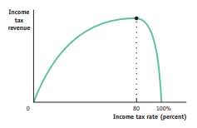
b. If the income tax rate is 0% (there is no tax), tax revenue is zero.
c. If the income tax rate is 100% (all of your income is taxed), you will have no income left after tax. Since people are unwilling to work if they receive no income after tax, no income will be earned. As a result, there is no income tax revenue.
d. For tax rates less than 80%, tax rate and tax revenue are positively related, so the Laffer curve has a positive slope. For tax rates higher than 80%, the relationship between tax rate and tax revenue is negative, so the Laffer curve has a negative slope. Therefore, the Laffer curve looks like the accompanying graph with a maximum point at a tax rate of 80%

